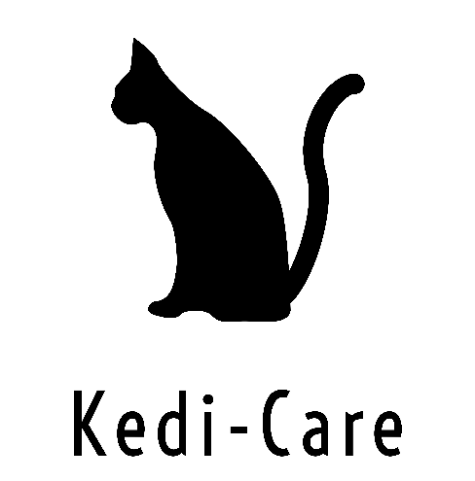

To make a booking enquiry please contact me by the following methods…

Get in touch
Telephone: 07731 858826
mailto:kedi-care@outlook.com
Address: Hednesford, Cannock United Kingdom

